4.okul web sitesiyle ilgili yapılması gerekenler:  
_ sayfaya e twinning projeleri ve e safety label web sitesi bağlantısı ver. Logolarını koy

[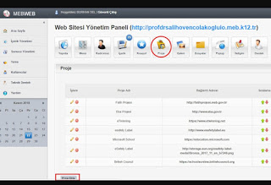](https://1.bp.blogspot.com/-jRoVRwXRhy8/XeDlNn14aMI/AAAAAAAAHO0/q2HaLSNXJnIW219IKGq77dg2jBBueIZawCLcBGAsYHQ/s1600/Screenshot_20191129-122955_Samsung%2BInternet.jpg)

[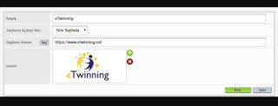](https://1.bp.blogspot.com/-YAVwiSBQs7w/XeDlk8__ttI/AAAAAAAAHPA/YWbfv_EWXngw0YbKohO6MLN9YegZvJHTgCLcBGAsYHQ/s1600/Screenshot_20191129-123123_Samsung%2BInternet.jpg)

[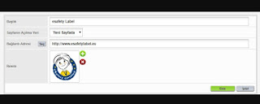](https://1.bp.blogspot.com/-iqInBYWj89U/XeDlk7gefjI/AAAAAAAAHO8/mvn9gyXE2lkEKS2YxKTbe8CjjWn1Hs6aACLcBGAsYHQ/s1600/Screenshot_20191129-123139_Samsung%2BInternet.jpg)

_e safety baglantisinj koy

[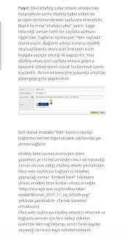](https://1.bp.blogspot.com/-aZRFpotIDXE/XeDmJdqnW4I/AAAAAAAAHPQ/wNFlLhPSJbwTTW1rCFgqPsZ240SCC3a0ACLcBGAsYHQ/s1600/Screenshot_20191129-123324_Samsung%2BInternet.jpg)

_menuye e twinning kisa yolu ekle

[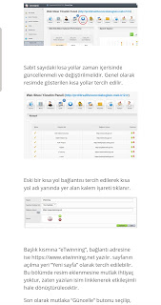](https://1.bp.blogspot.com/-U76S55isXYE/XeDmeXE0v5I/AAAAAAAAHPY/wxmr0MammQw2Zgu9CIucdXH3QB_rHUZRACLcBGAsYHQ/s1600/Screenshot_20191129-123534_Samsung%2BInternet.jpg)

_e güvenlikle ilgili yapılanları web sitesine koy  
_uygun temayi sec 4. Tema  
  
_e twinning projelerinin haberlerini koy  
_ sosyal medyanın kullanılması ile ilgili genelgeyi web sayfasına yükle  
_ okul güvenlik planınızı aşağıdaki resimdeki gibi ekleyin

[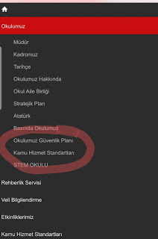](https://1.bp.blogspot.com/-FdZUOsQaYcs/Xe4deilt4mI/AAAAAAAAHRo/n21mtufta-AaTZs8tTceBzPbt-Jp4tk2ACLcBGAsYHQ/s1600/20191209_130814.jpg)

***  
Projelere öğrencilerde eklenmeli.  
***